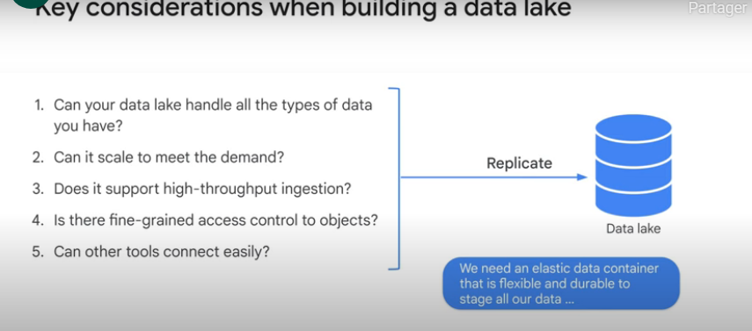

**ETL**: extract, transform, load (process used if we need to clean our raw data)

***Data Warehouse***: contains data that is formatted in a clean, queriable way

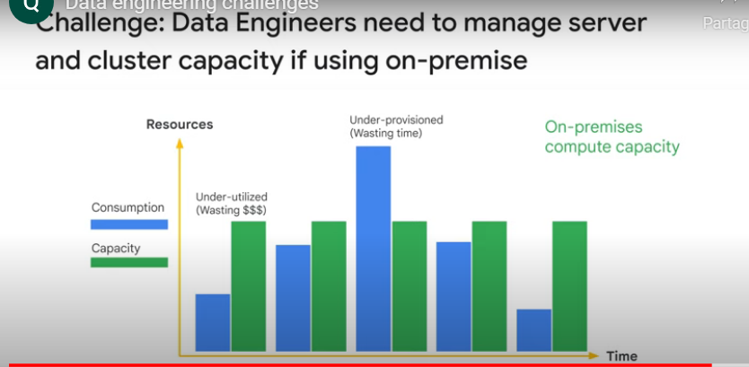

Data Warhouse vs Data lake

